CWEB280 Final Project PROPOSAL
Moe Khan

Frameworks I will use
Frontend:
- React/Vite
Backend:
- FastAPI + SQLite

New Features
In the release two/project2 submitted code, I did not implement the exam_or_quiz table, as I realized while working on the project that I already had the minimum number of tables required for project two, as per the project requirements.
Therefore, for this final release, I will implement the exam_or_quiz table, which will be used to keep track of exams/quizzes that students take, and will be added into the calendar page, as well as the upcoming page. This addition will bring the number of entities in the final project to four.
The other changes that will be implemented in this release will be:
- Breaking the current code in the front-end into components
- Creating custom hooks to communicate with the API
- Making all four entities implement CRUD interfaces

Description
My web application consists of a calendar scheduler that the user will use to see the dates of their classes, start and end times, and assignments coming up. The user will enter data in a form to schedule their classes and assignments.
The data stored will be:

Class
- Name of the class
- Credits of the class
- Days of Week
- Start and end date of the class
- Start and end time of the class
- Optional: Class syllabus file (file upload)

Assignment
- Assignment title
- Associated class
- Assignment due date
- Assignment due time
- Percentage the assignment is worth
- Optional: Assignment file (file upload)

There will be a navigation bar on the top every page that has the following pages:
- Home Page
- Calendar
- Upcoming
- Add Entry (Classes/Assignments)

Home
The Home Page will be a landing page that will have tabs with descriptions of the Calendar and Upcoming page.

Calendar
The Calendar page will be a UI calendar that will have the dates and times of the classes.

Upcoming
The upcoming page will consist of the classes upcoming/next date of the class, and the due date of an assignment, if any. This will be displayed on a table.
If the user also uploads a class syllabus or assignment requirement file, there will be functionality to select that file, which will open it in a new tab (see Figma for more clarity).

Add Entry
Finally, The Add Entry page is the page that the student will fill out a form to either add a class or add an assignment for an existing class (and upload appropriate files respectively).

Figma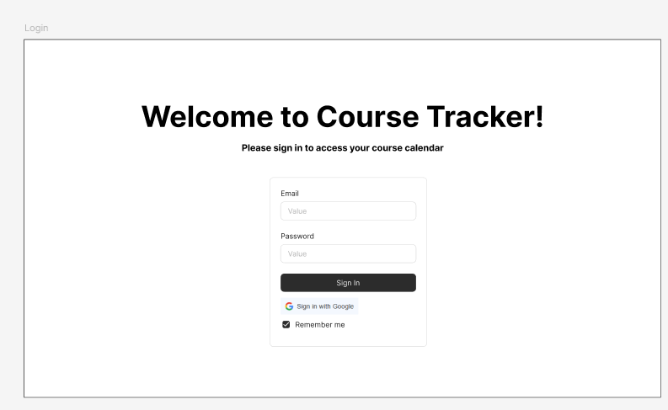 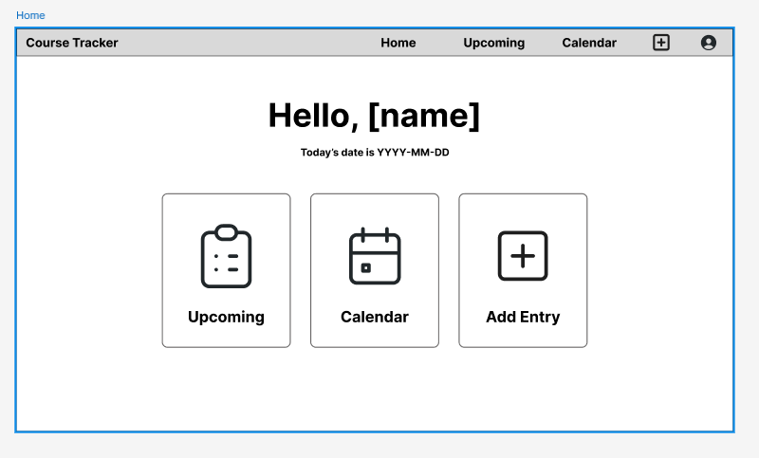
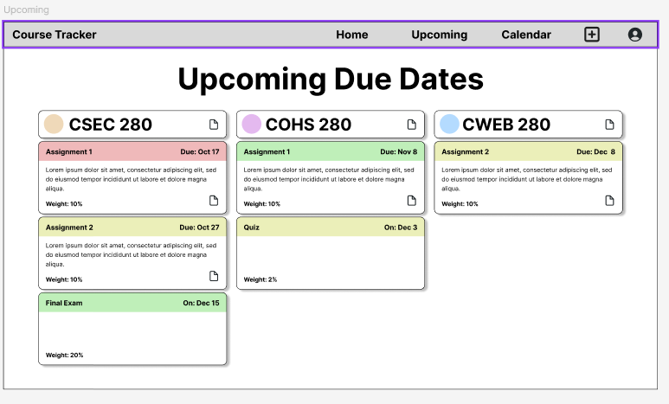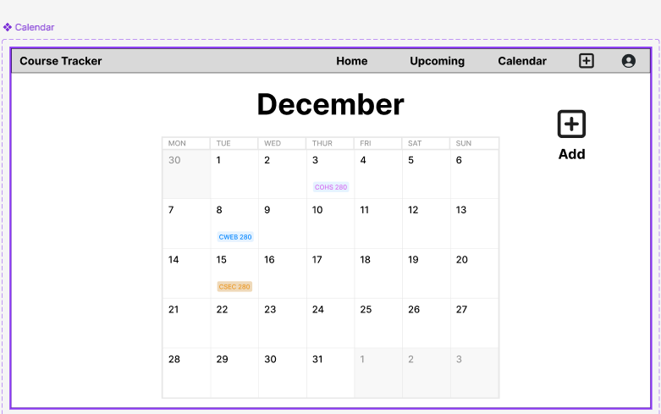
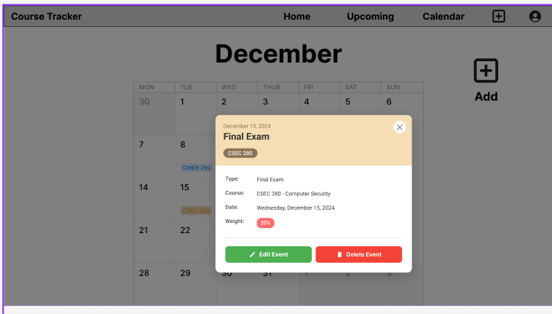
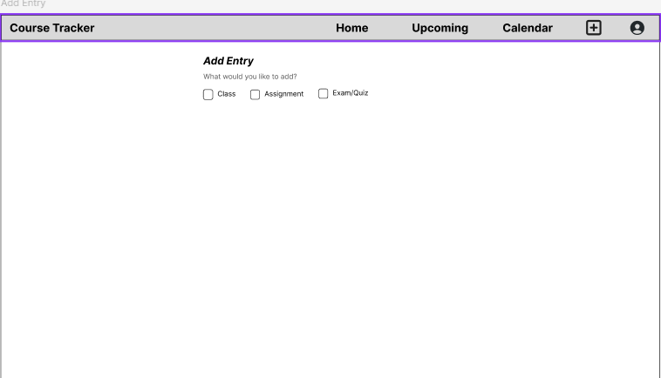
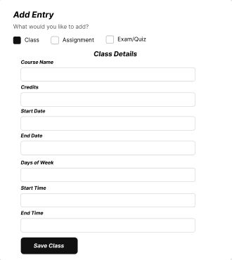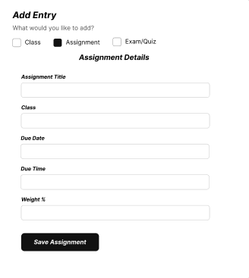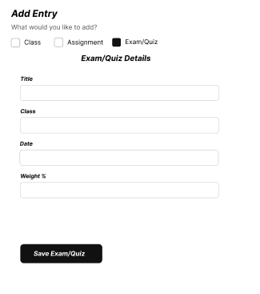

Class Diagram / ERD
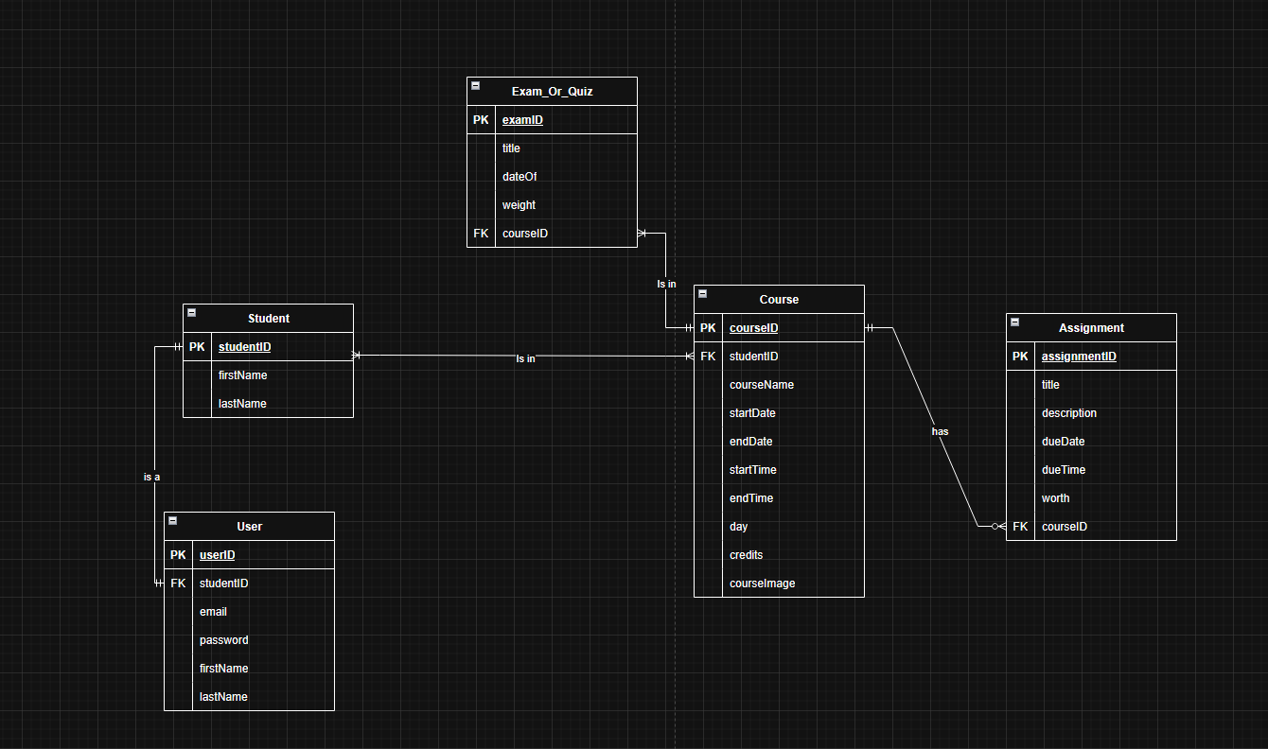

Testing Plan
Test Title | Program Input/Test Data | Expected Result
Empty forms are submitted | Fields in form are empty when submitting | Form validation fails and form is not submitted
Not all fields in form are filled | Some fields are filled, but some are left empty | Form validation fails and form is not submitted
All fields in form are filled with correct data | All fields in form are filled out properly | Form validation passes and form is submitted – Form details get added to calendar and/or upcoming page
Wrong data in form | Fields in form are filled with wrong/improper data | Form validation fails and form is not submitted
Login through google is selected – right credentials | User signs in with google and enters their correct google credentials | users token is saved in session storage – Website accepts token and allows user entry
Login through google is selected – wrong/no credentials | User signs in with google and enters incorrect google credentials | No user token is generated – user is not allowed entry
Login with wrong credentials | User enters incorrect credentials in login page | Credentials does not match credentials in DB, user is not allowed entry
Login with correct credentials | User enters correct credentials in login page | Credentials matches credentials in DB, user is allowed entry

